2.3.1 Functional Requirements
1. Description of Major Functionalities
The Shop Management System is an integrated platform for small and medium retail businesses to simplify daily operations. The system’s major functionalities focus on secure, efficient, and centralized management of shop tasks, reducing manual work and improving accuracy.
The platform includes:
- Authentication & Role Management – Secure login and access control for Admin and Employees.
- Dashboard – Overview of products, sales, and stock status.
- Product Management – Add, edit, delete, and search products.
- Sales & Invoice Management – Create sales invoices and update stock automatically.
- Reporting & Analytics – View sales history, stock levels, and top-selling products.
The primary objective is to replace manual record-keeping and fragmented tools (Excel, manual billing, multiple apps) with a single, organized system.
2.Core Functions ,Operations, and Features
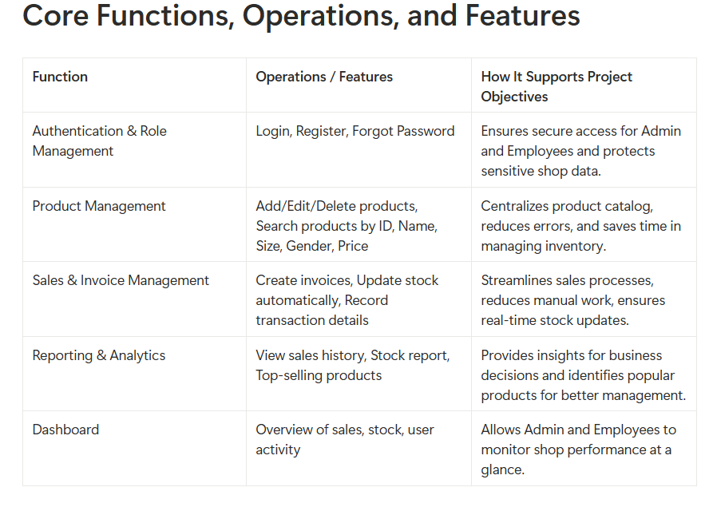
3. How Functions Support Project Objectives
Each module of the Shop Management System addresses specific real-world shop challenges:
1.Authentication & Role Management: Prevents unauthorized access and protects sensitive sales and stock data.
2.Product Management: Centralizes product records, avoids duplication, and simplifies updates.
3.Sales & Invoice Management: Automates stock updates and billing, reducing manual errors and saving time.
4.Reporting & Analytics: Provides transparency, improves decision-making, and reduces the risk of stock-outs.
5.Dashboard: Combines all key operations in one interface, reducing reliance on multiple tools and simplifying management.
4. Workflow Description
Workflow for Adding a New Product:
1.Admin logs into the system.
2.Navigates to the Product Management section.
3.Clicks “Add Product” and fills in details: Product Name, ID, Size, Gender, Quantity, Price.
4.Clicks “Save” to register the product.
5.The new product appears in the product catalog, available for sale and reporting.
5. Acceptance Criteria
- User Registration & Login: Admin or Employee must successfully log in after registration. System validates credentials and provides secure access.
- Product Addition: New products must appear immediately in the catalog with correct details.
- Sales Invoice Creation: Invoice creation updates stock automatically and records transaction details with date and time.
- Reporting: Sales and stock reports must reflect accurate data in real-time.
- Dashboard: Displays all key metrics correctly for Admin and Employees.

